**Global Quest Technologies**

**PROJECTREPORT ON**

**“Eduford University (Clone)”**

**Using Front-End Technologies**

Submitted by

Sripuram Ramya

(GQT-S0166)

Under the esteemed guidance of

Keshav

(Front-End Trainer at GQT)

________________ ___________________

Signature of Trainer Signature of CEO(GQT)

Keshav NARENDRA REDDY

Date: Date:

# INTRODUCTION5

**Eduford University (Clone) Scope of the document:-**

The "Eduford University Clone" project aims to create a virtual replica of Eduford University, a prominent educational institution. This report outlines the objectives, features, development process, challenges, and considerations involved in such an endeavor.

Eduford University is known for its quality education and comprehensive online platform. The project seeks to emulate its success and create a similar platform that offers online education, administrative tools, and student services , comprehensive course catalog with detailed descriptions and syllabi.

## HISTORY OF HTML:

**HTML** stands for **Hyper Text Markup Language**.

* It is used to share the information over the internet.
* HTML id developed by Tim Berner’s Lee in 1991.But officially in 1993.
* The First version of HTML consists of “18 tags”
* HTML follows certain rules and regulations setup by “**ISO**”.
* International Organization for standardization is set of rules and regulation are present in ‘**SGML**’ document.

## Versions of HTML

* **HTML-1** version in the year 1993.
* **Html-2** version in the year 1995.
* **HTML-3.02** version in the year 1997.
* **HTML-4.1** version in the year 1999.
* **HTML-5** version in the year 2014.

## Features of HTML

* + It is easy to Learn.
  + It is a tag based language.
  + HTML is supported by multiple browsers.
  + First web browser is Netscape navigation which was developed by the “Mosiac”.
  + It is a portable language.
  + **WORA** stands for ‘write once run anywhere’

## Limitation of HTML

* + HTML has less designing capabilities.
  + It is dependent on other technology such as CSS in order to develop well designed Webpages.
  + HTML has no programming capabilities.
  + Using HTML and CSS we can develop only static Web page.
  + In order to write the HTML code required an editor such as VS Code, Notepad, Eclipse.
  + In order to execute the HTML code we required Web browsers.Like Chrome, Firefox, edge, Opera Safari .

# CSS

* **CSS** stands for Cascading Style Sheets.
* It was developed by W3C to add stylings to the HTML elements.
* W3C stands for World Wide Web.com

**Versions of CSS:**

* **CSS-1** (level-1) in the year 1996.
* **CSS-2** (level-2) in the year 1998.
* **CSS-3** (level-3) in the year 1999.

**Why do we required CSS ?**

* Since HTML has less designing capabilities we cannot create well designed or most appealing Websites.
* Using HTML we cannot add style, animation and transitions to the Webpage.
* Therefore we require CSS to create well designed Webpages.

**Advantages of CSS**

* It allows to add styles, animation and variouses effects to the Webpage.
* It allows us to develop the Webpage rapidly. It is also know as RAD ( rapid application Developer).
* It allows us to separate from formatting develop page to the presentation of Webpage.
* It allows to create well designed Websites.

**Limitations of CSS**

* Using CSS we can perform static styles for the Webpages.
* In order to create dynamic styling for the Websites. We must make use of scripting language such as JavaScript and Libraries of JavaScript.

**Types of CSS:**

1. Inline CSS
2. Internal CSS
3. External CSS
4. Default Browser CSS

**Inline CSS:**

Defining all the CSS properties within the style attribute inside the opening of the tag is referred to as Inline CSS.

**Internal CSS:**

Defining all the CSS properties within <style> inside the HTML document is referred to as Internal CSS.

**External CSS:**

Defining all the CSS properties within as external Script or File with an extension CSS is referred to as External CSS.

* In order to link external CSS file within the HTML document we must use of <link>.
* The value for the ‘ref’ attribute should be ‘stylesheet’.

# Our Project

## Source Code:-

Home.html

<!DOCTYPE html>

<html lang="en">

<head>

    <meta charset="UTF-8">

    <meta name="viewport" content="width=device-width, initial-scale=1.0">

    <title>Eduford University</title>

    <link rel="stylesheet" href="home.css">

    <link rel="stylesheet" href="https://cdnjs.cloudflare.com/ajax/libs/font-awesome/4.7.0/css/font-awesome.min.css">

</head>

<body>

    <nav>

        <a href="home.html"><img src="logo.png" alt=""></a>

        <div class="nav-links">

            <ul>

                <li><a href="home.html">Home</a></li>

                <li><a href="about.html">About</a></li>

                <li><a href="course.html">Courses</a></li>

                <li><a href="blog.html">Blog</a></li>

                <li><a href="contact.html">Contact</a></li>

            </ul>

        </div>

    </nav>

    <div class="header">

        <div class="header-text">

            <h1>World's Biggest University</h1>

            <p>We’re a leading research university with a heart. Founded in the decade that the U.S. Constitution was signed, we’re the nation’s oldest Catholic and Jesuit university. Today we’re a forward-looking, diverse community devoted to social justice, restless inquiry and respect for each person’s individual needs and talents..</p>

            <a href="" class="btn">Visit Us To Know More</a>

        </div>

    </div>

    <div class="course">

        <h1>Courses we offer</h1>

        <p>Explore the intersection of technology and society. Learn about environmental justice. Take the famous Problem of God course. Our innovative courses inspire and invite you to help solve some of today’s most pressing local, national and global issues.</p>

        <div class="course-main">

            <div class="course-list">

                <h3>Undergraduate Programs</h3>

                <p class="para1">For decades, Eduford College has improved the health of our communities, one graduate at a time. The JoAnn McGrath School of Nursing and Health Professions, as one of the largest nursing schools in Wisconsin, offers a wide array of fully accredited nursing programs, guaranteed clinical placements and a technology-rich Center for Clinical Education.</p>

            </div>

            <div class="course-list">

                <h3>Graduate Programs</h3>

                <p class="para1">Building on our strong roots in leadership, health care and education, Eduford is proud to offer an array of coed graduate programs for women and men who are ready to advance their careers and grow as leaders. The Eduford College Community Psychology Master's program will help you to meet your goals of becoming a Licensed Professional Counselor.</p>

            </div>

            <div class="course-list">

                <h3>Post Graduation</h3>

                <p class="para1">The Eduford, as one of the largest nursing schools in Wisconsin, offers a wide array of fully accredited nursing programs, guaranteed clinical placements and a technology-rich Center for Clinical Education. The Eduford College Community Psychology Master's program will help you to meet your goals of becoming a Licensed Professional Counselor.</p>

            </div>

        </div>

    </div>

    <div class="campus">

        <h1>Our Global Campus</h1>

        <p>The University of Hartford's main campus is located on Bloomfield Avenue. Surrounded by green space, the main campus is divided into residential and academic buildings connected by a bridge that overlooks the north branch of the Park River, known to us as Hog River.</p>

        <div class="course-main">

            <div class="campus1">

                <figure>

                <img src="london.png" alt="" >

                <figcaption class="figcap">LONDON</figcaption>

               </figure>

            </div>

            <div class="campus1">

                <figure>

                    <img src="newyork.png" alt="">

                    <figcaption class="figcap">NEW YORK</figcaption>

                </figure>

            </div>

            <div class="campus1">

               <figure>

                <img src="washington.png" alt="">

                <figcaption class="figcap">WASHINGTON</figcaption>

               </figure>

            </div>

        </div>

    </div>

    <div class="facility">

            <h1>Our Facilities</h1>

            <p>We commit to meet the financial need of every admitted undergraduate student. We don’t consider your ability to pay when we review your application, and we don’t base our decision on whether you can cover the cost. If you’re accepted here, you belong here.</p>

            <div class="course-main">

                <div class="facility1">

                    <img src="library.png" alt="" class="img2">

                    <h3>World Class Library</h3>

                    <p>Pursue research at Eduford’s libraries, which include more than 3.5 million holdings. Whether your focus is on a specific discipline, interdisciplinary areas or emerging fields, our libraries offer academic resources, a maker hub, collaborative spaces and more.</p>

                </div>

                <div class="facility1">

                    <img src="basketball.png" alt=""class="img2" >

                    <h3>Largest Play Ground</h3>

                    <p>The College introduces students to philosophy and theology and challenges them to delve deeply into the arts, humanities, languages, social sciences and sciences.</p>

                </div>

                <div class="facility1">

                    <img src="cafeteria.png" alt=""class="img2" >

                    <h3>Tasty and Healthy Food.</h3>

                    <p>Whether students pursue studies in Arabic, chemistry, government or one of hundreds of other opportunities, they are part of a rich legacy of academic excellence designed to serve them well in an ever-changing world.</p>

                </div>

            </div>

    </div>

    <div class="test">

        <h1>What Our Student Says</h1>

        <p>We commit to meet the financial need of every admitted undergraduate student. We don’t consider your ability to pay when we review your application, and we don’t base our decision on whether you can cover the cost. If you’re accepted here, you belong here.</p>

        <div class="course-main">

            <div class="test1">

                <img src="user1.jpg" alt="">

                <div style="margin-left: 10px;">

                    <p>“Eduford is home to me not because of the fancy buildings like Healy Hall, or its prestigious reputation, but rather because of the university’s care for the whole person as each of us attempts to live our lives for others.”</p>

                    <h3>Anamika Saha</h3>

                    <span class="fa fa-star"></span>

                    <span class="fa fa-star"></span>

                    <span class="fa fa-star"></span>

                    <span class="fa fa-star"></span>

                    <span class="fa fa-star"></span>

                </div>

            </div>

            <div class="test1">

                <img src="user2.jpg" alt="">

                <div>

                    <p>“It’s likely that you will come to love some of the most amazing souls this campus has to offer. That love may come in the form of friendships that you know will last forever.”</p>

                    <h3>Abhishek Roy</h3>

                    <span class="fa fa-star"></span>

                    <span class="fa fa-star"></span>

                    <span class="fa fa-star"></span>

                    <span class="fa fa-star"></span>

                    <i class="fa fa-star-o"></i>

                </div>

            </div>

        </div>

    </div>

    <div class="enqu">

        <h1>Enroll For Our Various Online Courses

           <br> Anywhere from the World</h1>

        <a href="contact.html" class="btn">Contact Us</a>

    </div>

    <div class="about">

        <h4>About Us</h4>

        <p>We’re a leading research university with a heart. Founded in the decade that the U.S. Constitution was signed, we’re the nation’s oldest Catholic and Jesuit university. We’re a community of people who bridge our disparate experiences and identities. Meet the people and places that make Eduford home.</p>

        <div class="icons">

            <a href="https://www.facebook.com" target="_blank"><i class="fa fa-facebook"></i></a>

        <a href="https://www.twitter.com" target="_blank"><i class="fa fa-twitter"></i></a>

        <a href="https://www.instagram.com" target="_blank"> <i class="fa fa-instagram"></i></a>

        <a href="https://www.linkedin.com"target="_blank"><i class="fa fa-linkedin"></i></a>

        </div>

        <p>Made with <i class="fa fa-heart-o"></i>Mehedi Hasan John</p>

    </div>

</body>

</html>

**Home.css:**

*{

    margin: 0px;

    padding: 0px;

    box-sizing: border-box;

    font-family: sans-serif;

}

.header{

    border: 1px solid rgba(4,9,30,0.7);

    min-height: 100vh;

    width: 100%;

    background-image: linear-gradient(rgba(4,9,30,0.7),rgba(4,9,30,0.7)),url('uni.png');

    background-position: center;

    background-attachment: fixed;

    background-size: cover;

}

nav{

     height: 20px;

    background-color:brown;

    position: sticky;

    top: 0px;

    display:flex;

    padding: 2% 6%;

    justify-content: space-between;

    align-items: center;

}

nav img{

  width: 150px;

}

.nav-links{

    flex: 1;

    text-align: right;

}

.nav-links ul li{

    list-style: none;

    display: inline-block;

    padding: 8px 12px;

    position: relative;

}

.nav-links ul li a{

    color: white;

    text-decoration: none;

    font-size: 13px;

}

.nav-links ul li::after{

    content: '';

    width: 0%;

    height: 2px;

    background: #f44336;

    display: block;

    margin: auto;

    transition: 0.5s;

}

.nav-links ul li:hover::after{

  width: 100%;

}

.header-text{

    width: 90%;

    color: #fff;

    text-align: center;

    margin-top: 190px;

    margin-left: 50px;

}

.header-text h1{

    font-size: 62px;

}

.header-text p{

    margin: 20px 0 40px;

    line-height: 20px;

    font-size: 15px;

    color: #fff;

}

.btn{

    display: inline-block;

    text-decoration: none;

    color: #fff;

    border: 1px solid white;

    padding: 15px 20px;

    background: transparent;

    cursor: pointer;

}

.btn:hover{

    border: 1px solid rgb(124, 124, 250);

    transition: 0.8s;

    background-color: rgb(124, 124, 250);

}

@media (max-width:700px){

    .header-text h1{

        font-size: 62px;

    }

}

.course{

    width: 80%;

    margin: auto;

    text-align: center;

    padding-top: 100px;

}

h1{

    font-size: 36px;

    font-weight: 600;

}

p{

    padding: 20px;

    columns: #777;

    font-size: 16px;

    line-height: 22px;

}

.course-main{

    margin-top: 5%;

    justify-content: space-between;

    display: flex;

}

.course-list{

    flex-basis: 31%;

    margin-bottom: 5%;

    border: 2px solid #fff3f3;

    background-color: rgb(250, 226, 223);

    padding: 20px 12px;

    border-radius: 20px;

    box-sizing: border-box;

}

h3{

    text-align: center;

    font-weight: 600;

    margin: 10px 0;

}

.para1{

    color: #777;

   word-spacing: 3px;

}

.course-list:hover{

    box-shadow: 0px 0px  20px 0px gray;

}

.campus{

    width: 80%;

    margin: auto;

    text-align: center;

    padding-top: 50px;

}

.campus1{

    margin-bottom: 20px;

    overflow: hidden;

    margin-left: 20px;

}

.campus1 img{

    border-radius: 20px;

    width: 100%;

    height: 500px;

}

.campus1 .img2{

    height: 300px;

}

.figcap{

    color: rgb(46, 44, 44);

    font-weight: 700;

    padding-top:20px;

}

.facility{

    width: 80%;

    margin: auto;

    text-align: center;

    border-radius: 20px;

    padding: 100px;

}

.facility1{

flex-basis: 31%;

border-radius: 10px;

margin-bottom: 5%;

text-align:left;

}

.facility1 img{

    width: 100%;

    border-radius: 20px;

}

.facility1 p{

    padding: 0;

}

.facility1 h3{

    margin-top: 16px;

    margin-bottom: 15px;

    text-align: left;

}

.test{

    width: 80%;

    margin: auto;

    padding-top: 100px;

    text-align: center;

}

.test1{

    margin-left: 10px;

    border-radius: 20px;

    margin-bottom: 5%;

    text-align: left;

    background: #fff3f3;

    padding: 25px;

    cursor: pointer;

    display: flex;

}

.test1 img{

height: 40px;

margin-left: 5px;

margin-right: 30px;

border-radius: 50%;

}

.test1 p{

padding: 0;

}

.test1 h3{

 margin-top: 15px;

 text-align:left;

}

.enqu{

margin: 100px auto;

width: 100%;

background-image: linear-gradient(rgba(0,0,0,0.7),rgba(0,0,0,0.7)),url('uni1.png');

background-position: center;

background-size: cover;

background-attachment: fixed;

border-radius: 20px;

text-align: center;

padding: 100px 0;

height: 500px;

}

.enqu h1{

    margin-top: 40px;

    color: #fff;

    margin-bottom: 40px;

    padding: 0;

}

.about{

    width: 100%;

    text-align: center;

    padding: 20px 0;

}

.about h4{

    margin-bottom: 30px;

    margin-top: 20px;

    font-weight: 600;

}

.icons .fa{

color: #f44336;

margin: 0 13px;

cursor: pointer;

padding: 18px 0;

}

.fa-heart-o{

    color: #f44336;

}

**Output:**



Fig:1.1

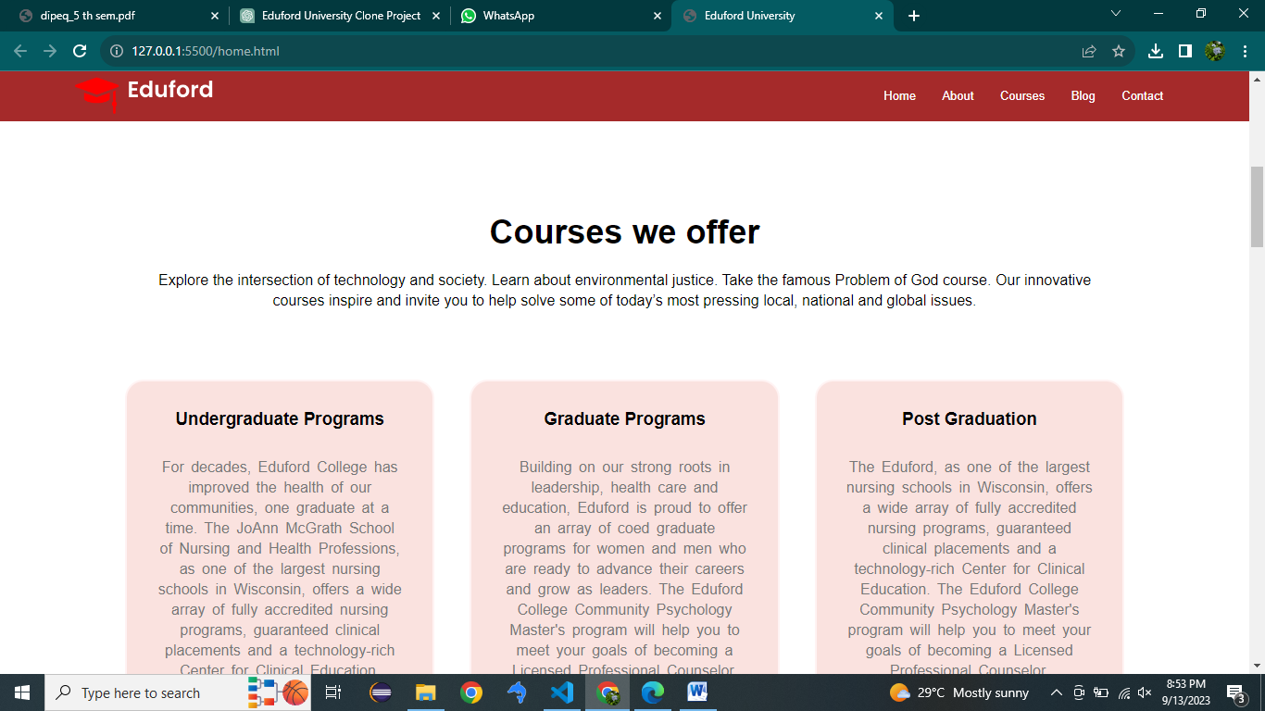

Fig:1.2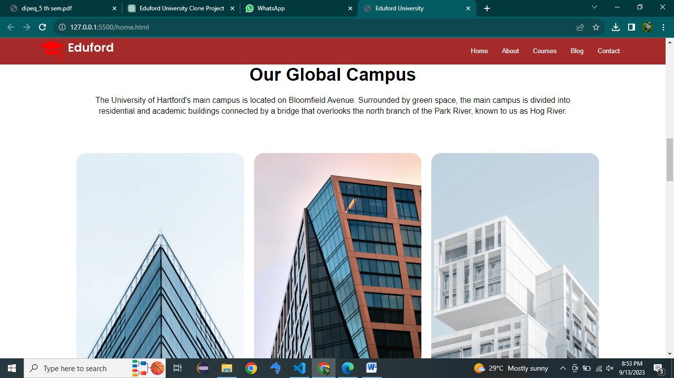

Fig:1.3

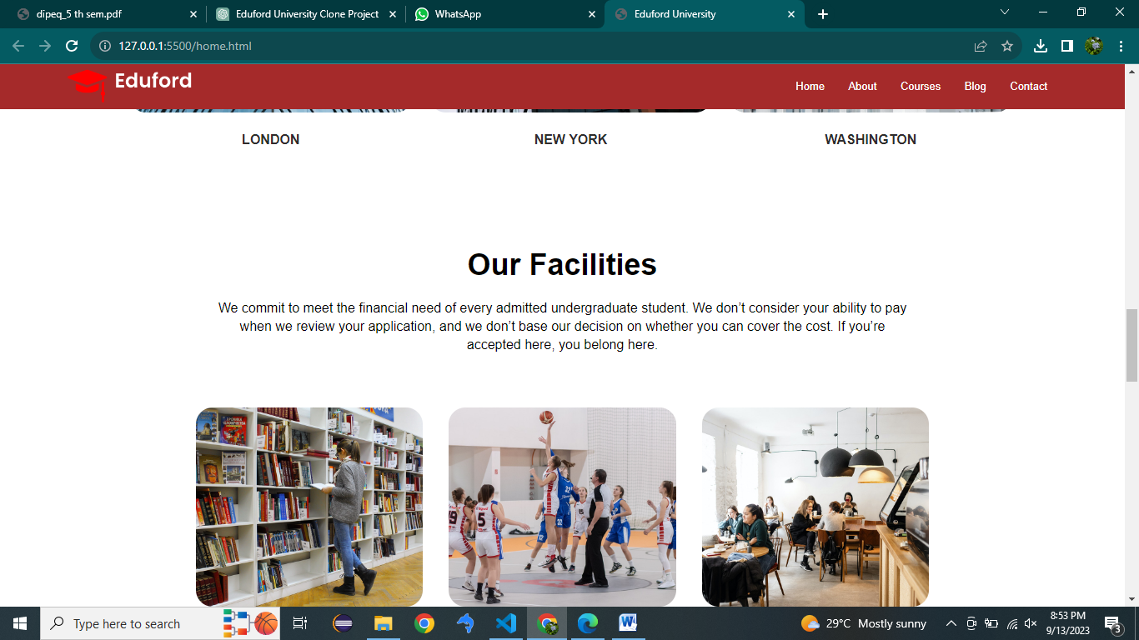

Fig:1.4

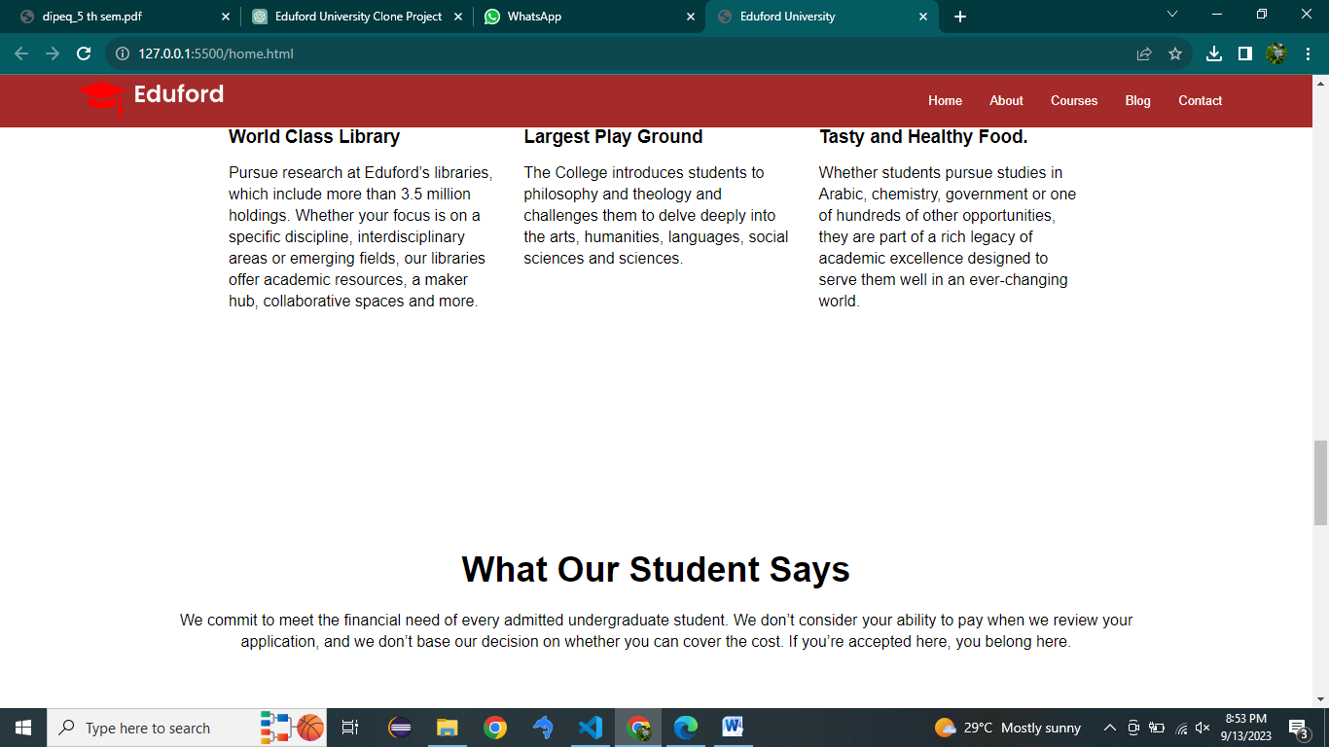

Fig:1.5

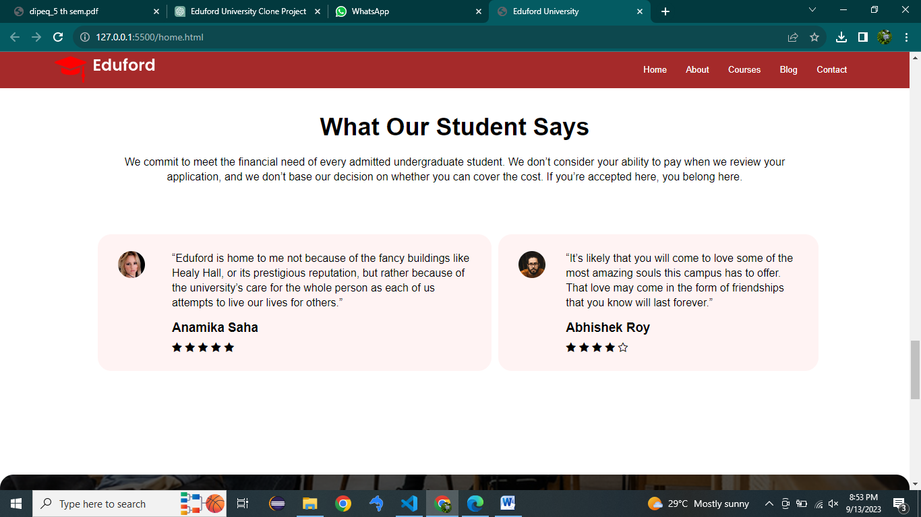

Fig:1.6

Fig:1.7

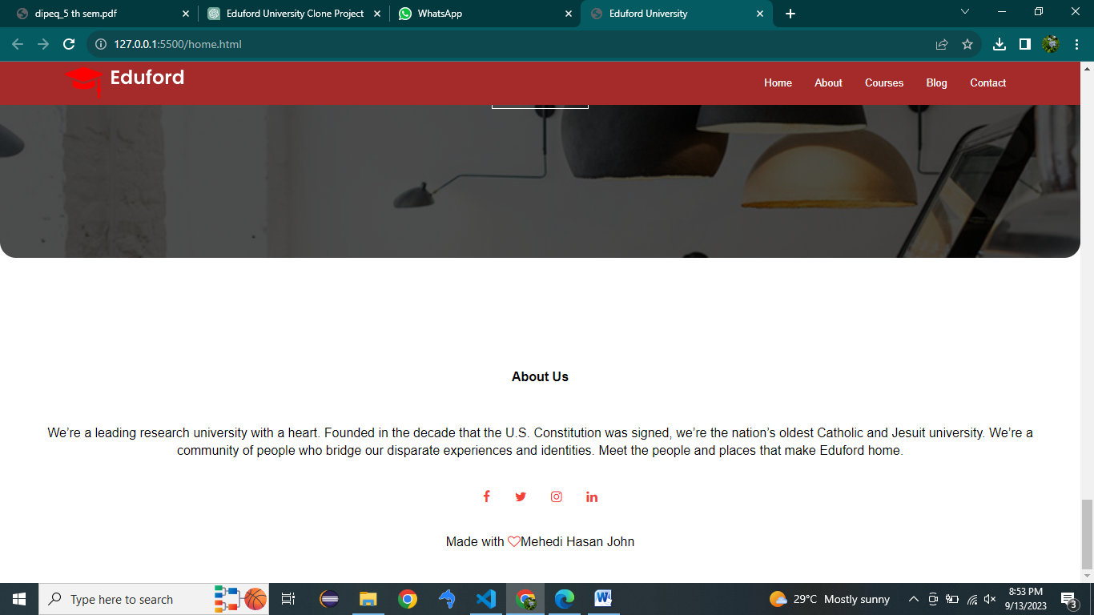

Fig:1.8

**About.html:**

<!DOCTYPE html>

<html lang="en">

<head>

    <meta charset="UTF-8">

    <meta name="viewport" content="width=device-width, initial-scale=1.0">

    <title>About Us</title>

    <link rel="stylesheet" href="about.css">

    <link rel="stylesheet" href="https://cdnjs.cloudflare.com/ajax/libs/font-awesome/4.7.0/css/font-awesome.min.css">

</head>

<body>

    <nav>

        <a href="home.html"><img src="logo.png" alt=""></a>

        <div class="nav-links">

            <ul>

                <li><a href="home.html">Home</a></li>

                <li><a href="about.html">About</a></li>

                <li><a href="course.html">Courses</a></li>

                <li><a href="blog.html">Blog</a></li>

                <li><a href="contact.html">Contact</a></li>

            </ul>

        </div>

    </nav>

    <div class="header">

            <h1 style="text-align: center; margin-top: 150px;color: white;">About Us</h1>

    </div>

    <div class="body1">

        <div class="about2">

            <h3>We are the world's largest teaching platform</h3>

            <p>Eduford University is one of the world’s leading academic and research institutions, offering a unique educational experience that prepares the next generation of global citizens to lead and make a difference in the world. We are a vibrant community of exceptional students, faculty, alumni and professionals dedicated to real-world applications of our research, scholarship, faith and service. Established in 1989, Eduford is the nation’s oldest Catholic and Jesuit university. Drawing upon the 450-year-old legacy of Jesuit education, we provide students with a world-class learning experience focused on educating the whole person through exposure to different faiths, cultures and beliefs.</p>

            <a href="about.html" class="btn">Explore Now</a>

        </div>

        <div class="about3">

            <img src="about.jpg" alt="">

        </div>

    </div>

    <div class="about">

        <h4>About Us</h4>

        <p>We’re a leading research university with a heart. Founded in the decade that the U.S. Constitution was signed, we’re the nation’s oldest Catholic and Jesuit university. <br>We’re a community of people who bridge our disparate experiences and identities. Meet the people and places that make Eduford home.</p>

        <div class="icons">

            <a href="https://www.facebook.com" target="_blank"><i class="fa fa-facebook"></i></a>

        <a href="https://www.twitter.com" target="_blank"><i class="fa fa-twitter"></i></a>

        <a href="https://www.instagram.com" target="_blank"> <i class="fa fa-instagram"></i></a>

        <a href="https://www.linkedin.com"target="_blank"><i class="fa fa-linkedin"></i></a>

        </div>

        <p>Made with <i class="fa fa-heart-o"></i>Mehedi Hasan John</p>

    </div>

</body>

</html>

**About.css:**

*{

    margin: 0px;

    padding: 0px;

    box-sizing: border-box;

    font-family: sans-serif;

}

.header{

    border: 1px solid rgba(4,9,30,0.7);

    min-height: 50vh;

    width: 100%;

    background-image: linear-gradient(rgba(4,9,30,0.7),rgba(4,9,30,0.7)),url('uni.png');

    background-position: center;

    background-attachment: fixed;

    background-size: cover;

}

nav{

    height: 20px;

    background-color:brown;

    position: sticky;

    top: 0px;

    display:flex;

    padding: 2% 6%;

    justify-content: space-between;

    align-items: center;

}

nav img{

  width: 150px;

}

.nav-links{

    flex: 1;

    text-align: right;

}

.nav-links ul li{

    list-style: none;

    display: inline-block;

    padding: 8px 12px;

    position: relative;

}

.nav-links ul li a{

    color: white;

    text-decoration: none;

    font-size: 13px;

}

.nav-links ul li::after{

    content: '';

    width: 0%;

    height: 2px;

    background: #f44336;

    display: block;

    margin: auto;

    transition: 0.5s;

}

.nav-links ul li:hover::after{

  width: 100%;

}

.about{

    margin-top: 40px;

    width: 100%;

    text-align: center;

    padding: 20px 0;

}

.about h4{

    margin-bottom: 30px;

    margin-top: 20px;

    font-weight: 600;

}

.about p{

    line-height: 25px;

}

.icons{

    margin-top: 30px;

}

.icons .fa{

color: #f44336;

margin: 0 13px;

cursor: pointer;

padding: 18px 0;

}

.fa-heart-o{

    color: #f44336;

}

.body2{

    display: flex;

    width: 100%;

}

.about2{

    margin-top: 90px;

    margin-left: 90px;

    width: 40%;

}

.about2 h3{

    color: rgb(63, 61, 61);

    font-size: 27px;

    font-weight: 700;

}

.about2 p{

    color: rgb(71, 69, 69);

    padding-top: 20px;

    word-spacing: 3px;

    line-height: 25px;

}

.about3 img{

    float: right;

    margin-top: -420px;

    margin-right: 140px;

    width: 40%;

    height: 400px;

}

.btn{

    margin-top: 30px;

    display: inline-block;

    text-decoration: none;

    color: blue;

    border: 1px solid red;

    padding: 15px 20px;

    background: transparent;

    cursor: pointer;

}

.btn:hover{

    color: white;

    border: 1px solid rgb(124, 124, 250);

    transition: 0.8s;

    background-color: rgb(124, 124, 250);

}

**Output:**

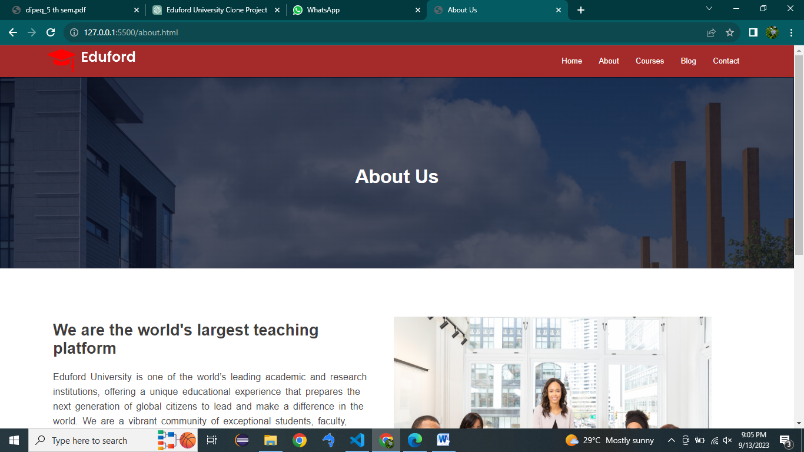

Fig:2.1

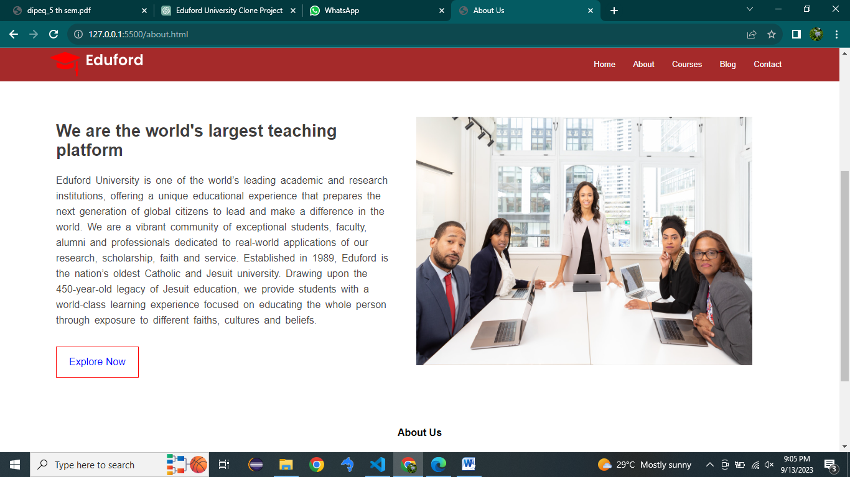

Fig:2.2

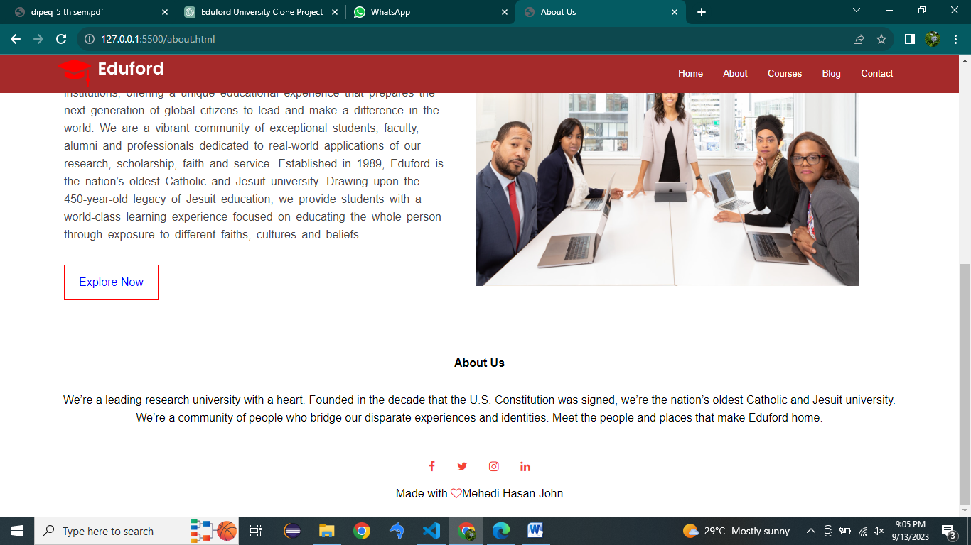

Fig:2.3

**Courses.html:**

<!DOCTYPE html>

<html lang="en">

<head>

    <meta charset="UTF-8">

    <meta name="viewport" content="width=device-width, initial-scale=1.0">

    <title>courses</title>

    <link rel="stylesheet" href="course.css">

    <link rel="stylesheet" href="https://cdnjs.cloudflare.com/ajax/libs/font-awesome/4.7.0/css/font-awesome.min.css">

</head>

<body>

    <nav>

        <a href="home.html"><img src="logo.png" alt=""></a>

        <div class="nav-links">

            <ul>

                <li><a href="home.html">Home</a></li>

                <li><a href="about.html">About</a></li>

                <li><a href="course.html">Courses</a></li>

                <li><a href="blog.html">Blog</a></li>

                <li><a href="">Contact</a></li>

            </ul>

        </div>

    </nav>

    <div class="header">

            <h1  style="text-align: center; margin-top: 100px;color: white;">Courses</h1>

    </div>

    <div class="course">

        <h1>Courses we offer</h1>

        <p>Explore the intersection of technology and society. Learn about environmental justice. Take the famous Problem of God course. Our innovative courses inspire and invite you to help solve some of today’s most pressing local, national and global issues.</p>

        <div class="course-main">

            <div class="course-list">

                <h3>Undergraduate Programs</h3>

                <p class="para1">For decades, Eduford College has improved the health of our communities, one graduate at a time. The JoAnn McGrath School of Nursing and Health Professions, as one of the largest nursing schools in Wisconsin, offers a wide array of fully accredited nursing programs, guaranteed clinical placements and a technology-rich Center for Clinical Education.</p>

            </div>

            <div class="course-list">

                <h3>Graduate Programs</h3>

                <p class="para1">Building on our strong roots in leadership, health care and education, Eduford is proud to offer an array of coed graduate programs for women and men who are ready to advance their careers and grow as leaders. The Eduford College Community Psychology Master's program will help you to meet your goals of becoming a Licensed Professional Counselor.</p>

            </div>

            <div class="course-list">

                <h3>Post Graduation</h3

                <p class="para1">The Eduford, as one of the largest nursing schools in Wisconsin, offers a wide array of fully accredited nursing programs, guaranteed clinical placements and a technology-rich Center for Clinical Education. The Eduford College Community Psychology Master's program will help you to meet your goals of becoming a Licensed Professional Counselor.</p>

            </div>

        </div>

    </div>

    <div class="facility">

        <h1>Our Facilities</h1>

        <p>We commit to meet the financial need of every admitted undergraduate student. We don’t consider your ability to pay when we review your application, and we don’t base our decision on whether you can cover the cost. If you’re accepted here, you belong here.</p>

        <div class="course-main">

            <div class="facility1">

                <img src="library.png" alt="" class="img2">

                <h3>World Class Library</h3>

                <p>Pursue research at Eduford’s libraries, which include more than 3.5 million holdings. Whether your focus is on a specific discipline, interdisciplinary areas or emerging fields, our libraries offer academic resources, a maker hub, collaborative spaces and more.</p>

            </div>

            <div class="facility1">

                <img src="basketball.png" alt=""class="img2" >

                <h3>Largest Play Ground</h3>

                <p>The College introduces students to philosophy and theology and challenges them to delve deeply into the arts, humanities, languages, social sciences and sciences.</p>

            </div>

            <div class="facility1">

                <img src="cafeteria.png" alt=""class="img2" >

                <h3>Tasty and Healthy Food.</h3>

                <p>Whether students pursue studies in Arabic, chemistry, government or one of hundreds of other opportunities, they are part of a rich legacy of academic excellence designed to serve them well in an ever-changing world.</p>

            </div>

        </div>

</div>

<div class="about">

    <h4>About Us</h4>

    <p>We’re a leading research university with a heart. Founded in the decade that the U.S. Constitution was signed, we’re the nation’s oldest Catholic and Jesuit university. We’re a community of people who bridge our disparate experiences and identities. Meet the people and places that make Eduford home.</p>

    <div class="icons">

        <a href="https://www.facebook.com" target="_blank"><i class="fa fa-facebook"></i></a>

        <a href="https://www.twitter.com" target="_blank"><i class="fa fa-twitter"></i></a>

        <a href="https://www.instagram.com" target="_blank"> <i class="fa fa-instagram"></i></a>

        <a href="https://www.linkedin.com"target="_blank"><i class="fa fa-linkedin"></i></a>

    </div>

    <p>Made with <i class="fa fa-heart-o"></i>Mehedi Hasan John</p>

</div>

</body>

</html>

**Courses.css:**

*{

    margin: 0px;

    padding: 0px;

    box-sizing: border-box;

    font-family: sans-serif;

}

.header{

    border: 1px solid rgba(4,9,30,0.7);

    min-height: 50vh;

    width: 100%;

    background-image: linear-gradient(rgba(4,9,30,0.7),rgba(4,9,30,0.7)),url('uni.png');

    background-position: center;

    background-attachment: fixed;

    background-size: cover;

}

nav{

    height: 20px;

    border: 1px solid brown;

    background-color: brown;

    position: sticky;

    top: 0px;

    display:flex;

    padding: 2% 6%;

    justify-content: space-between;

    align-items: center;

}

nav img{

  width: 150px;

}

.nav-links{

    flex: 1;

    text-align: right;

}

.nav-links ul li{

    list-style: none;

    display: inline-block;

    padding: 8px 12px;

    position: relative;

}

.nav-links ul li a{

    color: white;

    text-decoration: none;

    font-size: 13px;

}

.nav-links ul li::after{

    content: '';

    width: 0%;

    height: 2px;

    background: #f44336;

    display: block;

    margin: auto;

    transition: 0.5s;

}

.nav-links ul li:hover::after{

  width: 100%;

}

.course{

    width: 80%;

    margin: auto;

    text-align: center;

    padding-top: 100px;

}

h1{

    font-size: 36px;

    font-weight: 600;

}

p{

    padding: 20px;

    columns: #777;

    font-size: 16px;

    line-height: 22px;

}

.course-main{

    margin-top: 5%;

    justify-content: space-between;

    display: flex;

}

.course-list{

    flex-basis: 31%;

    margin-bottom: 5%;

    border: 2px solid #fff3f3;

    background-color: rgb(250, 226, 223);

    padding: 20px 12px;

    border-radius: 20px;

    box-sizing: border-box;

}

h3{

    text-align: center;

    font-weight: 600;

    margin: 10px 0;

}

.para1{

    color: #777;

   word-spacing: 3px;

}

.course-list:hover{

    box-shadow: 0px 0px  20px 0px gray;

}

.facility{

    width: 80%;

    margin: auto;

    text-align: center;

    border-radius: 20px;

    padding: 100px;

}

.facility1{

flex-basis: 31%;

border-radius: 10px;

margin-bottom: 5%;

text-align:left;

}

.facility1 img{

    width: 100%;

    border-radius: 20px;

}

.facility1 p{

    padding: 0;

}

.facility1 h3{

    margin-top: 16px;

    margin-bottom: 15px;

    text-align: left;

}

.about{

    width: 100%;

    text-align: center;

    padding: 20px 0;

}

.about h4{

    margin-bottom: 30px;

    margin-top: 20px;

    font-weight: 600;

}

.icons .fa{

color: #f44336;

margin: 0 13px;

cursor: pointer;

padding: 18px 0;

}

.fa-heart-o{

    color: #f44336;

}

**Output:**



Fig:3.1

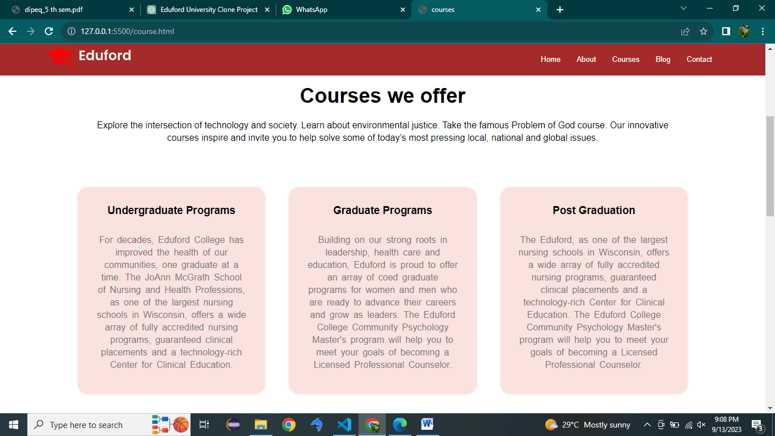

Fig:3.2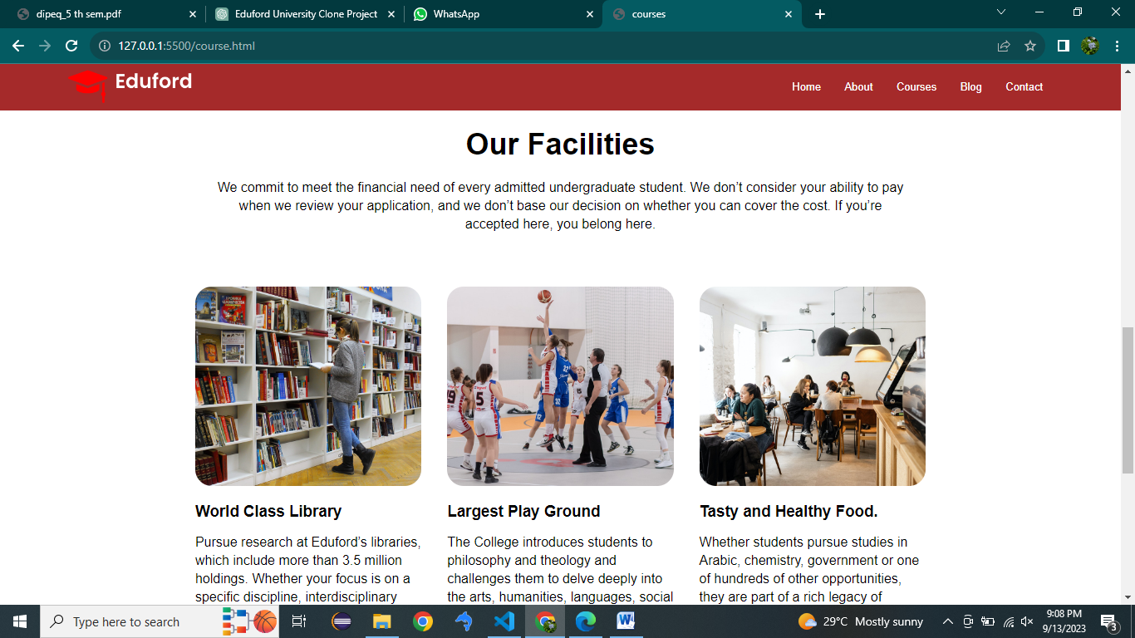

Fig:3.3

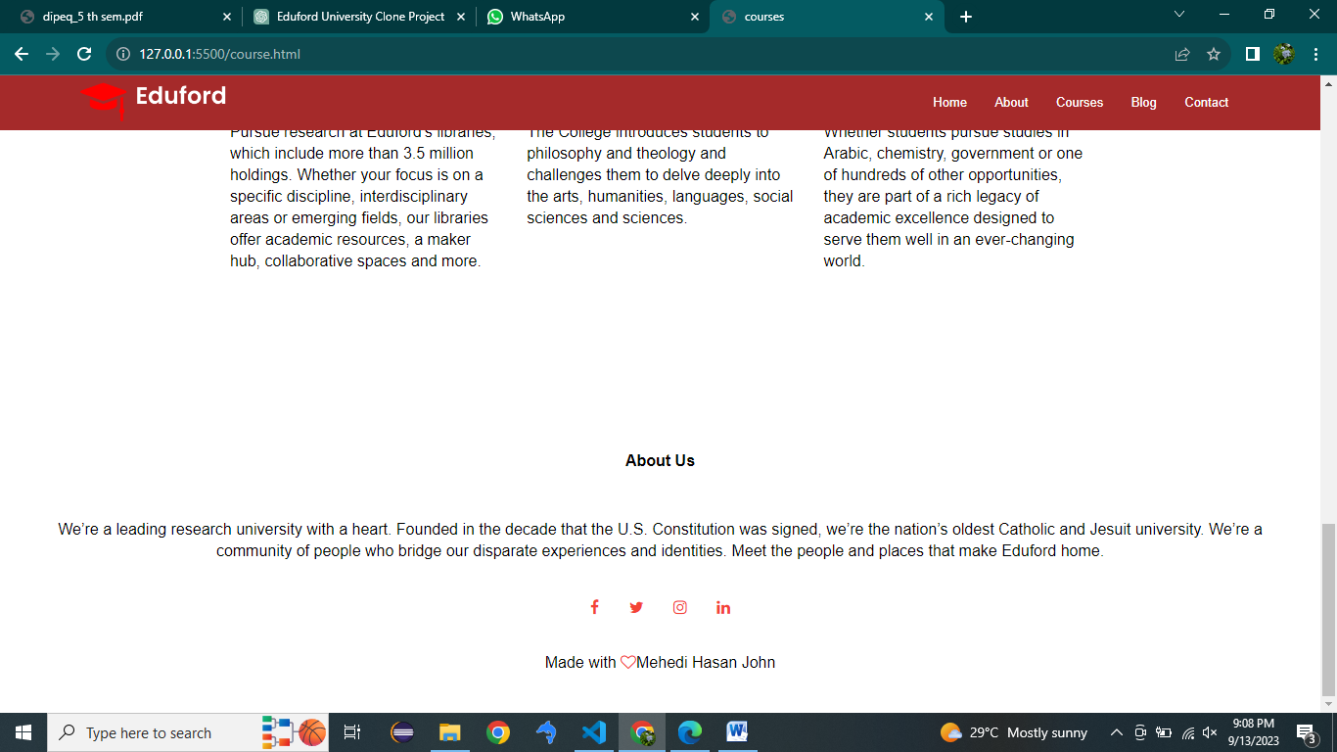

Fig:3.4

**Blog.html:**

<!DOCTYPE html>

<html lang="en">

<head>

    <meta charset="UTF-8">

    <meta name="viewport" content="width=device-width, initial-scale=1.0">

    <title>Blog</title>

    <link rel="stylesheet" href="blog.css">

    <link rel="stylesheet" href="https://cdnjs.cloudflare.com/ajax/libs/font-awesome/4.7.0/css/font-awesome.min.css">

</head>

<body>

    <nav>

        <a href="home.html"><img src="logo.png" alt=""></a>

        <div class="nav-links">

            <ul>

                <li><a href="home.html">Home</a></li>

                <li><a href="about.html">About</a></li>

                <li><a href="course.html">Courses</a></li>

                <li><a href="blog.html">Blog</a></li>

                <li><a href="contact.html">Contact</a></li>

            </ul>

        </div>

    </nav>

    <div class="header">

            <h1 style="text-align: center; margin-top: 100px;color: white;">Our Certificate & Online Programs For 2022</h1>

    </div>

    <div class="post">

        <div class="img2">

            <img src="certificate.jpg" alt="" style="height: 450px;

            width: 100%;">

            <h2>Our Certificate & Online <br> Programs For 2022</h2>

            <p>In sollicitudin elit dolor. Suspendisse lacinia vitae mi et tincidunt. Etiam magna magna, bibendum non est in, hendrerit aliquet urna. Donec elementum, lectus non tempor laoreet, nisl tellus vestibulum felis, eget ornare neque ante vel arcu. Nullam nec vulputate ligula, suscipit congue velit. Ut elementum vulputate nulla suscipit pretium. Curabitur et mi urna. Vestibulum sit amet pulvinar erat, id varius lacus. Proin nunc mi, tempus auctor euismod in, bibendum id tortor. Quisque eget hendrerit enim. Etiam consectetur sapien nisl, in porta erat placerat eu. Maecenas fermentum nisi eget mi bibendum dignissim. Integer varius interdum est, eu mollis sem euismod a. Nullam eget blandit mi.</p>

            <p>In sollicitudin elit dolor. Suspendisse lacinia vitae mi et tincidunt. Etiam magna magna, bibendum non est in, hendrerit aliquet urna. Donec elementum, lectus non tempor laoreet, nisl tellus vestibulum felis, eget ornare neque ante vel arcu. Nullam nec vulputate ligula, suscipit congue velit. Ut elementum vulputate nulla suscipit pretium. Curabitur et mi urna. Vestibulum sit amet pulvinar erat, id varius lacus. Proin nunc mi, tempus auctor euismod in, bibendum id tortor. Quisque eget hendrerit enim. Etiam consectetur sapien nisl, in porta erat placerat eu. Maecenas fermentum nisi eget mi bibendum dignissim. Integer varius interdum est, eu mollis sem euismod a. Nullam eget blandit mi.</p>

            <p>In sollicitudin elit dolor. Suspendisse lacinia vitae mi et tincidunt. Etiam magna magna, bibendum non est in, hendrerit aliquet urna. Donec elementum, lectus non tempor laoreet, nisl tellus vestibulum felis, eget ornare neque ante vel arcu. Nullam nec vulputate ligula, suscipit congue velit. Ut elementum vulputate nulla suscipit pretium. Curabitur et mi urna. Vestibulum sit amet pulvinar erat, id varius lacus. Proin nunc mi, tempus auctor euismod in, bibendum id tortor. Quisque eget hendrerit enim. Etiam consectetur sapien nisl, in porta erat placerat eu. Maecenas fermentum nisi eget mi bibendum dignissim. Integer varius interdum est, eu mollis sem euismod a. Nullam eget blandit mi.</p>

            <p>In sollicitudin elit dolor. Suspendisse lacinia vitae mi et tincidunt. Etiam magna magna, bibendum non est in, hendrerit aliquet urna. Donec elementum, lectus non tempor laoreet, nisl tellus vestibulum felis, eget ornare neque ante vel arcu. Nullam nec vulputate ligula, suscipit congue velit.</p>

            <div class="comment">

                <h3>Leave a comment</h3>

                <form action="">

                    <input type="text" name="" id="" placeholder="Enter Name">

                    <input type="email" name="" id="" placeholder="Enter Email">

                    <input type="text" name="" id="" placeholder="Your Comment..">

                </form>

                <a href="" class="btn">Post Comment</a>

            </div>

        </div>

    </div>

    <div class="tab">

        <h2>Post Categories</h2>

        <table cellspacing="20px">

            <tbody>

                <tr>

                    <td>Buisness Analytics  </td>

                    <td>21</td>

                </tr>

                <tr>

                    <td>Technologies</td>

                    <td>20</td>

                </tr>

                <tr>

                    <td>Database Analytics</td>

                    <td>11</td>

                </tr>

                <tr>

                    <td>Machine Learning</td>

                    <td>16</td>

                </tr>

                <tr>

                    <td>Covid-19 Analytics</td>

                    <td>41</td>

                </tr>

            </tbody>

        </table>

    </div>

    <div class="about">

        <h4>About Us</h4>

        <p>We’re a leading research university with a heart. Founded in the decade that the U.S. Constitution was signed, we’re the nation’s oldest Catholic and Jesuit university. We’re a community of people who bridge our disparate experiences and identities. Meet the people and places that make Eduford home.</p>

        <div class="icons">

            <a href="https://www.facebook.com" target="_blank"><i class="fa fa-facebook"></i></a>

        <a href="https://www.twitter.com" target="_blank"><i class="fa fa-twitter"></i></a>

        <a href="https://www.instagram.com" target="_blank"> <i class="fa fa-instagram"></i></a>

        <a href="https://www.linkedin.com"target="_blank"><i class="fa fa-linkedin"></i></a>

        </div>

        <p>Made with <i class="fa fa-heart-o"></i>Mehedi Hasan John</p>

    </div>

</body>

</html>

**Blog.css:**

*{

    margin: 0px;

    padding: 0px;

    box-sizing: border-box;

    font-family: sans-serif;

}

.header{

    border: 1px solid rgba(4,9,30,0.7);

    min-height: 50vh;

    width: 100%;

    background-image: linear-gradient(rgba(4,9,30,0.7),rgba(4,9,30,0.7)),url('uni.png');

    background-position: center;

    background-attachment: fixed;

    background-size: cover;

}

nav{

    height: 20px;

    border: 1px solid brown;

    background-color: brown;

    position: sticky;

    top: 0px;

    display:flex;

    padding: 2% 6%;

    justify-content: space-between;

    align-items: center;

}

nav img{

  width: 150px;

}

.nav-links{

    flex: 1;

    text-align: right;

}

.nav-links ul li{

    list-style: none;

    display: inline-block;

    padding: 8px 12px;

    position: relative;

}

.nav-links ul li a{

    color: white;

    text-decoration: none;

    font-size: 13px;

}

.nav-links ul li::after{

    content: '';

    width: 0%;

    height: 2px;

    background: #f44336;

    display: block;

    margin: auto;

    transition: 0.5s;

}

.nav-links ul li:hover::after{

  width: 100%;

}

.post{

    width: 50%;

  margin-left: 100px;

   margin-top: 150px;

}

.img2{

    width: 100%;

}

.img2 h2{

    font-size: 42px;

}

.img2 p{

    padding-top: 20px;

    color: rgb(90, 88, 88);

    white-space: 3px;

    line-height: 25px;

}

.comment{

    margin-top: 30px;

    border: 2px solid gray;

}

.comment h3{

    padding: 30px;

    font-size: 26px;

}

input{

    padding: 15px;

    width: 90%;

    margin-left: 30px;

    margin-bottom: 30px;

    background-color: rgb(101, 224, 224);border:none;

    font-size: 20px;

    color: black;

}

input:hover{

    border-color: blue;

    background-color: gainsboro;

}

.btn{

    margin-left: 30px;

    display: inline-block;

    text-decoration: none;

    color:black;

    border: 1px solid gray;

    padding: 15px 20px;

    background: transparent;

    cursor: pointer;

    background-color: gray;

    margin-bottom: 30px;

}

.btn:hover{

    border: 1px solid rgb(124, 124, 250);

    transition: 0.8s;

    background-color: rgb(124, 124, 250);

}

.tab{

    width: 32%;

    float: right;

    margin-top: -132.1%;

    margin-right: 90px;

}

table{

    width: 100%;

}

.tab h2{

    text-align: center;

    background-color: red;

    color: white;

    padding: 15px;

}

.about{

    width: 100%;

    text-align: center;

    padding: 20px 0;

}

.about h4{

    margin-bottom: 30px;

    margin-top: 20px;

    font-weight: 600;

}

.icons .fa{

color: #f44336;

margin: 0 13px;

cursor: pointer;

padding: 18px 0;

}

.fa-heart-o{

    color: #f44336;

}

**Output:**



Fig:4.1



Fig:4.2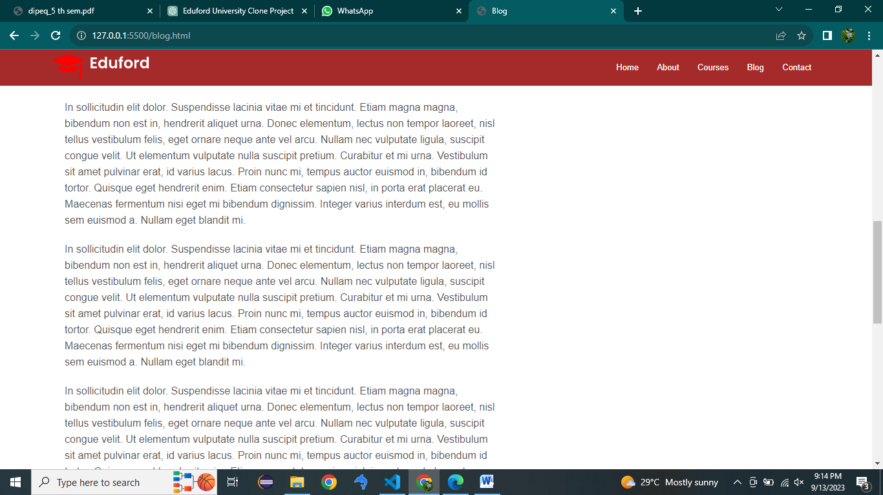

Fig:4.3

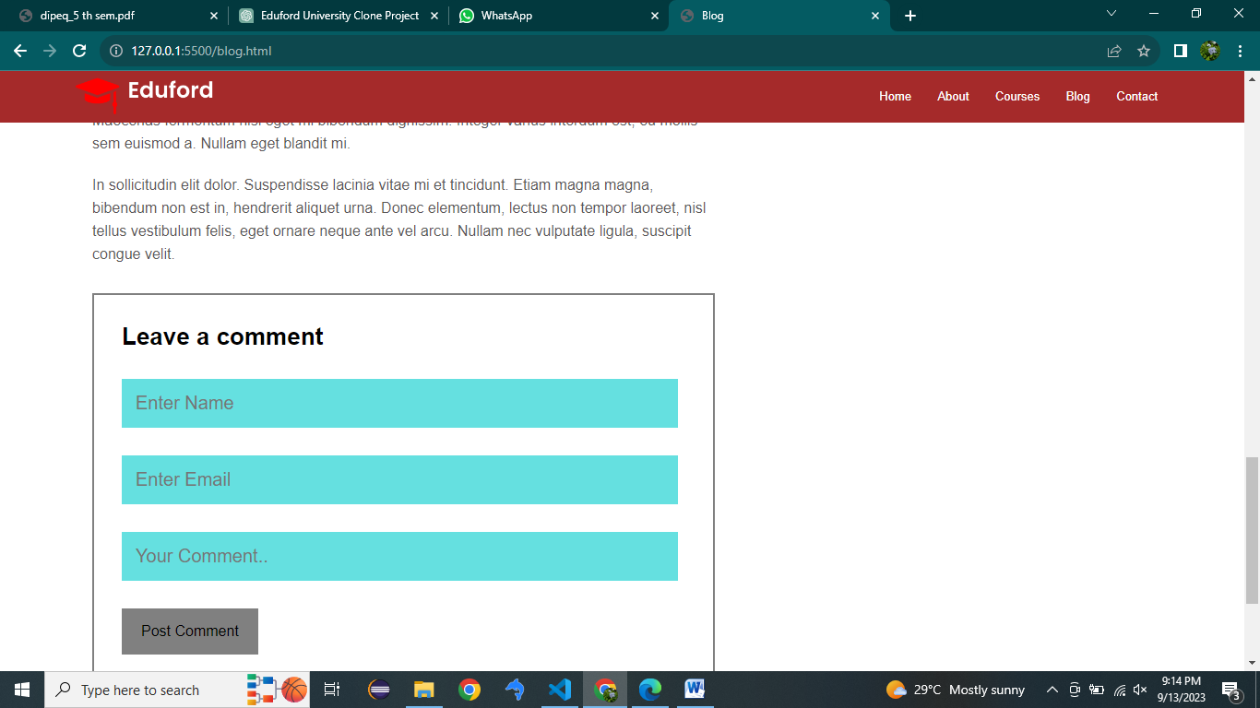

Fig:4.4

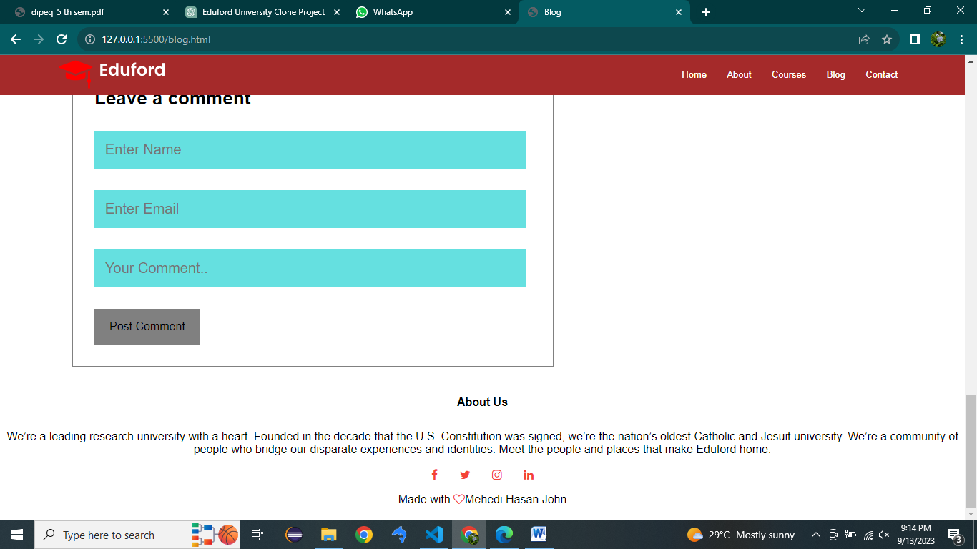

Fig:4.5

**Contact.html:**

<!DOCTYPE html>

<html lang="en">

<head>

    <meta charset="UTF-8">

    <meta name="viewport" content="width=device-width, initial-scale=1.0">

    <title>Contact Us</title>

    <link rel="stylesheet" href="contact.css">

    <link rel="stylesheet" href="https://cdnjs.cloudflare.com/ajax/libs/font-awesome/4.7.0/css/font-awesome.min.css">

</head>

<body>

    <nav>

        <a href="home.html"><img src="logo.png" alt=""></a>

        <div class="nav-links">

            <ul>

                <li><a href="home.html">Home</a></li>

                <li><a href="about.html">About</a></li>

                <li><a href="course.html">Courses</a></li>

                <li><a href="blog.html">Blog</a></li>

                <li><a href="contact.html">Contact</a></li>

            </ul>

        </div>

    </nav>

    <div class="header">

            <h1 style="text-align: center; margin-top: 100px;color: white;">Contact Us</h1>

    </div>

    <div class="map">

        <iframe src="https://www.google.com/maps/embed?pb=!1m14!1m8!1m3!1d7303.806011460997!2d90.393415!3d23.750838!3m2!1i1024!2i768!4f13.1!3m3!1m2!1s0x3755b8a2ac98817b%3A0xf48ca75c1bdfc0f2!2sBangladesh%20Association%20of%20Software%20and%20Information%20Services%20(BASIS)!5e0!3m2!1sen!2sbd!4v1694235740537!5m2!1sen!2sbd" width="96%" height="550" style="border:0;" allowfullscreen="" loading="lazy" referrerpolicy="no-referrer-when-downgrade"></iframe>

    </div>

    <div class="contact">

     <div class="cnt">

        <h3><i class="fa fa-home"></i>University of Engineering and Management,<br> &nbsp;&nbsp;&nbsp;&nbsp;&nbsp;Gurukul Campus</h3>

        <p> University of Engineering and Management, Gurukul Campus Jaipur, Rajasthan, India</p>

     </div>

     <div class="cnt">

        <h3><i class="fa fa-phone"></i>+91 6378281761</h3>

        <p>Monday to Saturday, 10AM to 6PM</p>

     </div>

     <div class="cnt">

        <h3><i class="fa fa-envelope"></i>amalendupandey56@gmail.com</h3>

        <p>Email us your queries</p>

     </div>

    </div>

    <div class="comment">

        <form action="">

            <input type="text" name="" id="" placeholder="Enter Name">

            <input type="email" name="" id="" placeholder="Enter Email">

            <input type="text" name="" id="" placeholder="Your Comment..">

        </form>

        <a href="" class="btn">Send a Message</a>

    </div>

    <div class="about">

        <h4>About Us</h4>

        <p>We’re a leading research university with a heart. Founded in the decade that the U.S. Constitution was signed, we’re the nation’s oldest Catholic and Jesuit university. <br>We’re a community of people who bridge our disparate experiences and identities. Meet the people and places that make Eduford home.</p>

        <div class="icons">

        <a href="https://www.facebook.com" target="_blank"><i class="fa fa-facebook"></i></a>

        <a href="https://www.twitter.com" target="_blank"><i class="fa fa-twitter"></i></a>

        <a href="https://www.instagram.com" target="_blank"> <i class="fa fa-instagram"></i></a>

        <a href="https://www.linkedin.com"target="_blank"><i class="fa fa-linkedin"></i></a>

        </div>

        <p>Made with <i class="fa fa-heart-o"></i>Mehedi Hasan John</p>

    </div>

</body>

</html>

**Contact.css:**

*{

    margin: 0px;

    padding: 0px;

    box-sizing: border-box;

    font-family: sans-serif;

}

.header{

    border: 1px solid rgba(4,9,30,0.7);

    min-height: 50vh;

    width: 100%;

    background-image: linear-gradient(rgba(4,9,30,0.7),rgba(4,9,30,0.7)),url('uni.png');

    background-position: center;

    background-attachment: fixed;

    background-size: cover;

}

nav{

    position: sticky;

    top: 0px;

    height: 20px;

    border: 1px solid brown;

    background-color: brown;

    display:flex;

    padding: 2% 6%;

    justify-content: space-between;

    align-items: center;

}

nav img{

  width: 150px;

}

.nav-links{

    flex: 1;

    text-align: right;

}

.nav-links ul li{

    list-style: none;

    display: inline-block;

    padding: 8px 12px;

    position: relative;

}

.nav-links ul li a{

    color: white;

    text-decoration: none;

    font-size: 13px;

}

.nav-links ul li::after{

    content: '';

    width: 0%;

    height: 2px;

    background: #f44336;

    display: block;

    margin: auto;

    transition: 0.5s;

}

.nav-links ul li:hover::after{

  width: 100%;

}

.header-text{

    width: 90%;

    color: #fff;

    position: absolute;

    top: 60%;

    left: 50%;

    transform: translate(-50%,-50%);

    text-align: center;

}

.header-text h1{

    font-size: 52px;

}

.map{

    border: 0px solid;

    width: 90%;

    margin: auto;

    margin: 80px;

}

.contact{

   width: 50%;

   margin: 90px;

   padding: 30px;

}

.cnt{

    padding: 30px;

}

.cnt h3{

    margin-left: 10px;

}

.cnt p{

    padding-top: 10px;

    margin-left: 39px;

}

.cnt i{

    padding-right: 10px;

    color: red;

}

.comment{

    width: 40%;

    margin-left: 690px;

    margin-top: -480px;

}

input{

    border-radius: 8px;

    padding: 15px;

    width: 90%;

    margin-left: 30px;

    margin-bottom: 30px;

    background-color: white;

    font-size: 20px;

    color: black;

    border: 1px solid gray;

}

input:hover{

    border-color: blue;

    background-color: gainsboro;

}

.btn{

    margin-left: 30px;

    display: inline-block;

    text-decoration: none;

    color:black;

    border: 1px solid gray;

    padding: 15px 20px;

    background: transparent;

    cursor: pointer;

    background-color: gray;

    margin-bottom: 30px;

}

.btn:hover{

    border: 1px solid rgb(124, 124, 250);

    transition: 0.8s;

    background-color: rgb(124, 124, 250);

}

.about{

    margin-top: 40px;

    width: 100%;

    text-align: center;

    padding: 20px 0;

}

.about h4{

    margin-bottom: 30px;

    margin-top: 20px;

    font-weight: 600;

}

.about p{

    line-height: 25px;

}

.icons{

    margin-top: 30px;

}

.icons .fa{

color: #f44336;

margin: 0 13px;

cursor: pointer;

padding: 18px 0;

}

.fa-heart-o{

    color: #f44336;

}

**Output:**

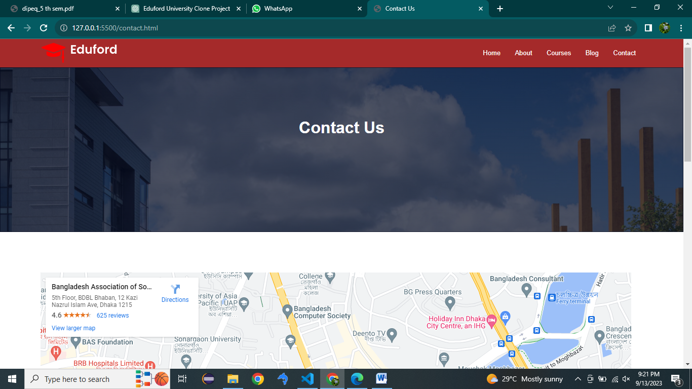

Fig:5.1

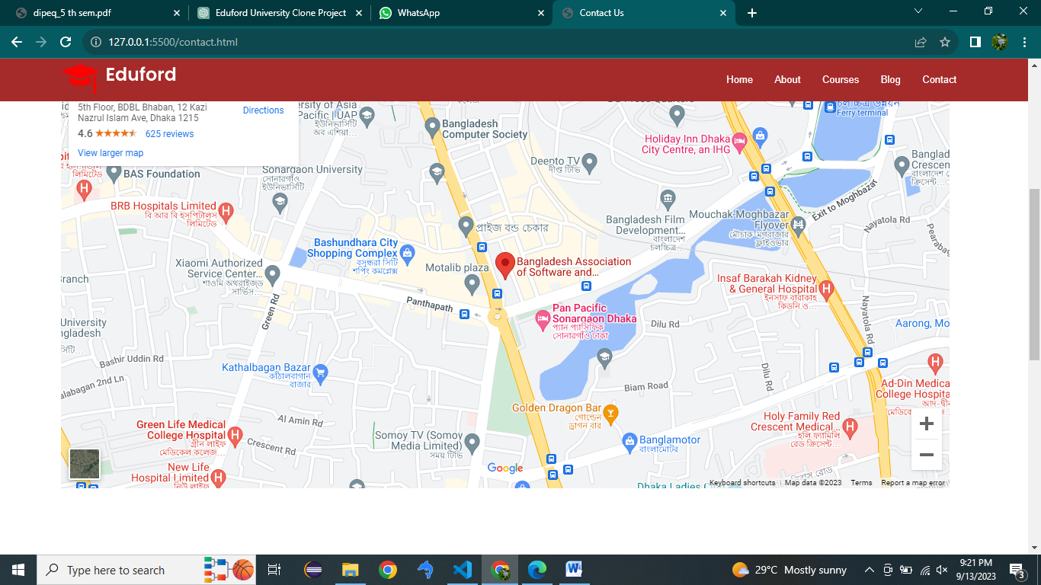

Fig:5.2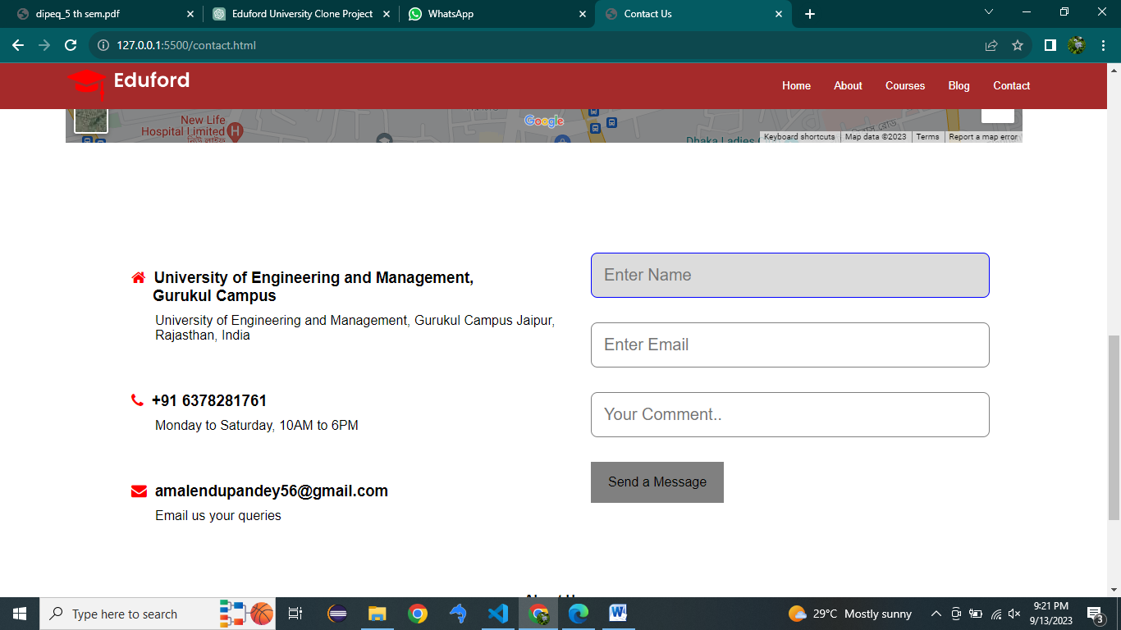

Fig:5.3

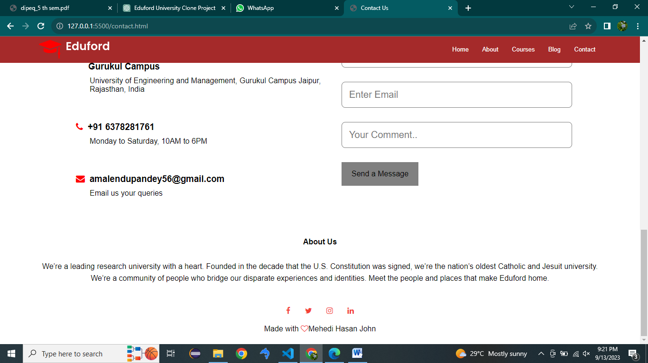

Fig:5.4

# Conclusion

In Conclusion ,The "Eduford University Clone" project presents an ambitious and complex undertaking aimed at replicating key aspects of Eduford University's online educational platform. Throughout the scope of this document, we have outlined the project's objectives, inclusions, exclusions, constraints, and assumptions to provide a comprehensive understanding of its scope and boundaries.

It is crucial to emphasize that while this project holds potential, it also faces significant legal, ethical, and technical challenges. The replication of an educational institution, especially without consent or appropriate licenses, may raise concerns related to copyright infringement and misrepresentation. Additionally, the competitive landscape, with Eduford University's established reputation and resources, adds complexity to the project's success.